**How to use Movie Reviewer**  
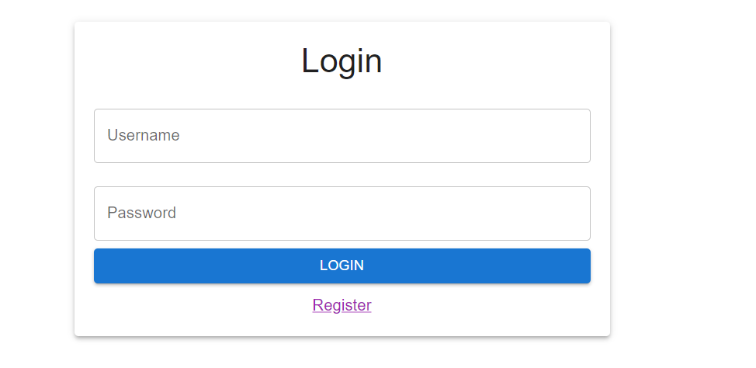  
1. Login with your user, if you do not have a user, then you can register a user.

2. Click the add review button below the title you wish to review.  
3. Add a comment and a rating for the selected movie.

4. If you would like to view a list of reviews, click on the hamburger menu to the right and select reviews.  
5. Here you can see a list of all reviews based on a particular title.

6. Search for reviews based on a movies title.

7. Click the pencil icon to edit the comment or rating of a review **Note you can only edit reviews you have created.  
8. Click the bin icon to delete a review **Note you can only delete reviews you have created.